INSTRU MENTAL

Furniture maker Arnt Arntzen and assemblage artist Valerie Arntzen have collaborated on a new body of work titled "Instru Mental".
Working with non-functioning musical instruments they blend their creative and technical backgrounds to deconstruct and reconstruct
the instruments into new and unexpected combinations.

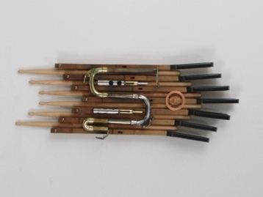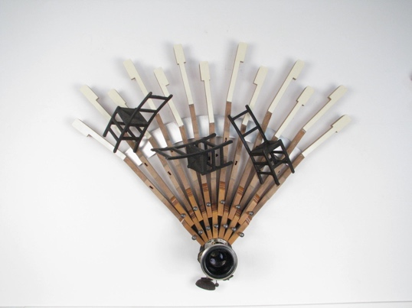
Ebony and Hickory Musical Chairs
24” x 28”. $350 22” x 8” $450

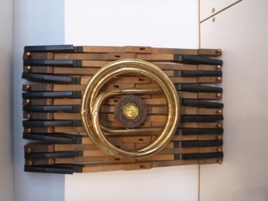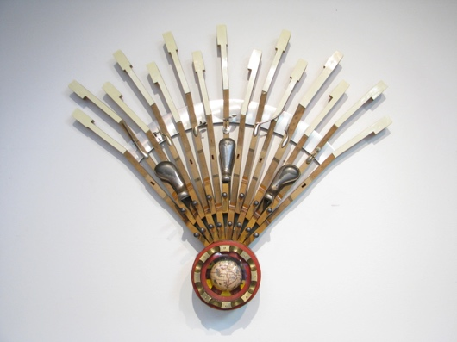
Sharp Awakening World Music
25” x 28” $350 15” x 10”.$450

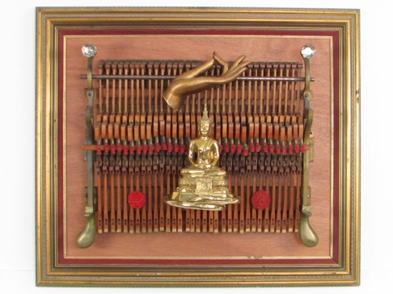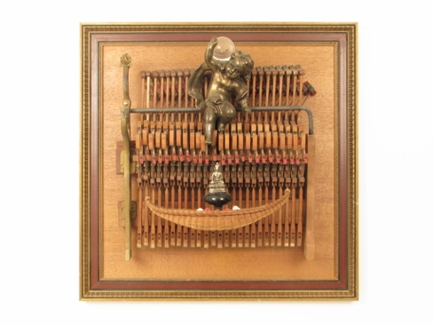
Piano Forte Harmony of the Wandering Spirits
24” x 24” $750 25” x 29” $750

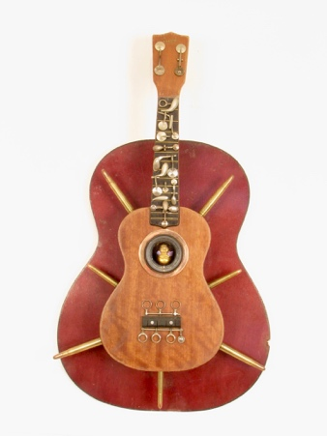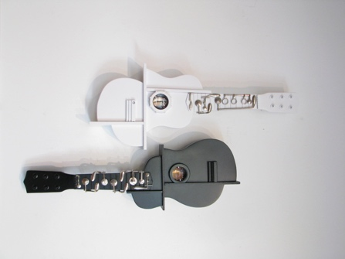
Bullets to Buddha 2 Uke and Yang
28” x 14” x 3” $450 26” x 15” $450 each

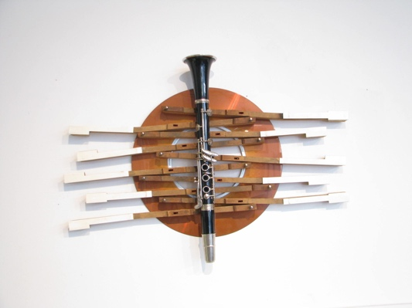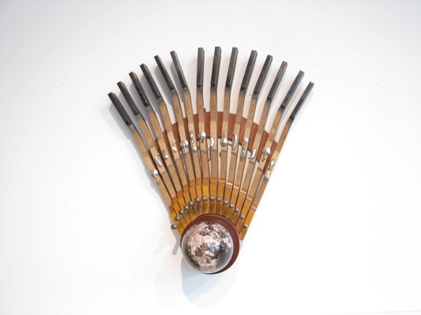
Jazz Messenger Black Orpheus
20” x 19” $450 19” x 26” $450

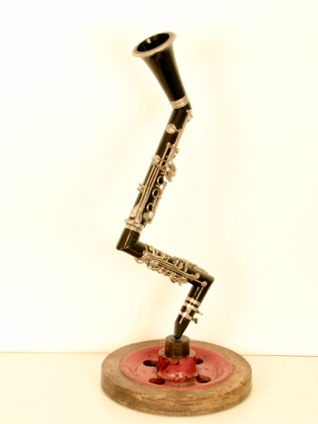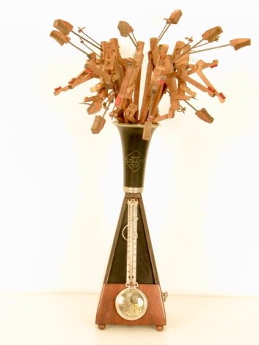
Parisian Swing Allegro
20’ x 11” $450 24” x 10” $450

